SIMATS ENGINEERING
ASSESSMENT TOOL 1
COURSE NAME: Cryptography and Network Security
COURSE CODE: CSA51

COURSE OUTCOME COVERED

CO3: Examine cryptographic hash algorithms, digital signature schemes, and assess Kerberos and X.509 authentication frameworks for ensuring integrity, authentication, and non-repudiation.CO (BL4 , BL5)

Assessment Tool Weightage: 40%

QUESTIONS: 5 TOTAL MARKS: 25

EXPERIMENTS

Code of Conduct:

I N DIMPLE BLOSSOM (192411227) (Name / Reg No) certify that this submission is my original work and that I have adhered to the guidelines specified for this assessment.
I understand that any violation of academic integrity rules will result in disciplinary action.

Signature of the student:

Annexure A
Experiments

- Implement and compare MD5 and Secure Hash Algorithm (SHA-256) in Python by hashing multiple input messages. Analyze their collision resistance and performance differences.

- Develop a Python program to implement a Digital Signature scheme using RSA. Demonstrate message signing and signature verification, and analyze its effectiveness in ensuring integrity and authentication.

- Write a Python program to simulate HMAC (Hash-based Message Authentication Code) using a chosen hash function. Compare its security properties with a simple hash-based integrity check.

- Implement a simplified Kerberos authentication mechanism in Python to simulate ticket generation, distribution, and validation between a client and server. Analyze its effectiveness in preventing replay attacks.

- Develop a Python-based implementation of either the ElGamal or Schnorr digital signature scheme, and evaluate its security features compared to standard digital signature approaches.

RUBRICS FOR CALCULATION:

Criteria | Weightage | Level 4 – Exemplary | Level 3 – Proficient | Level 2 – Developing | Level 1 – Beginning
Understanding of Concepts | 25 | Demonstrates thorough understanding and effectively integrates multiple concepts/technologies | Good understanding with proper integration of most concepts | Basic understanding; limited or partial integration | Poor understanding; unable to integrate concepts
Experimental Design | 30 | Well-planned, systematic implementation with optimal solution | Correct implementation with minor issues | Basic implementation with errors or inefficiencies | Incorrect or incomplete implementation
Use of Tools | 20 | Effective and advanced use of tools/technologies with proper configuration | Appropriate use of tools with correct execution | Limited or inconsistent use of tools | Incorrect or minimal use of tools
Analysis of Results | 15 | Insightful analysis with accurate interpretation and validation of results | Good analysis with reasonable interpretation | Basic analysis with limited insights | Poor or incorrect analysis of results
Documentation | 10 | Clear, well-structured documentation with diagrams, code, and results | Organized documentation with necessary details | Basic documentation with missing details | Poor or incomplete documentation

1. MD5 vs SHA-256 Comparison in Python

Aim
To implement and compare MD5 and SHA-256 hashing algorithms using multiple input messages and analyze their performance and collision resistance.

Theory

MD5
- Produces a 128-bit hash value.
- Faster but vulnerable to collision attacks.
- Considered insecure for modern applications.

SHA-256
- Produces a 256-bit hash value.
- Strong collision resistance.
- Widely used in secure systems and blockchain applications.

Python Program
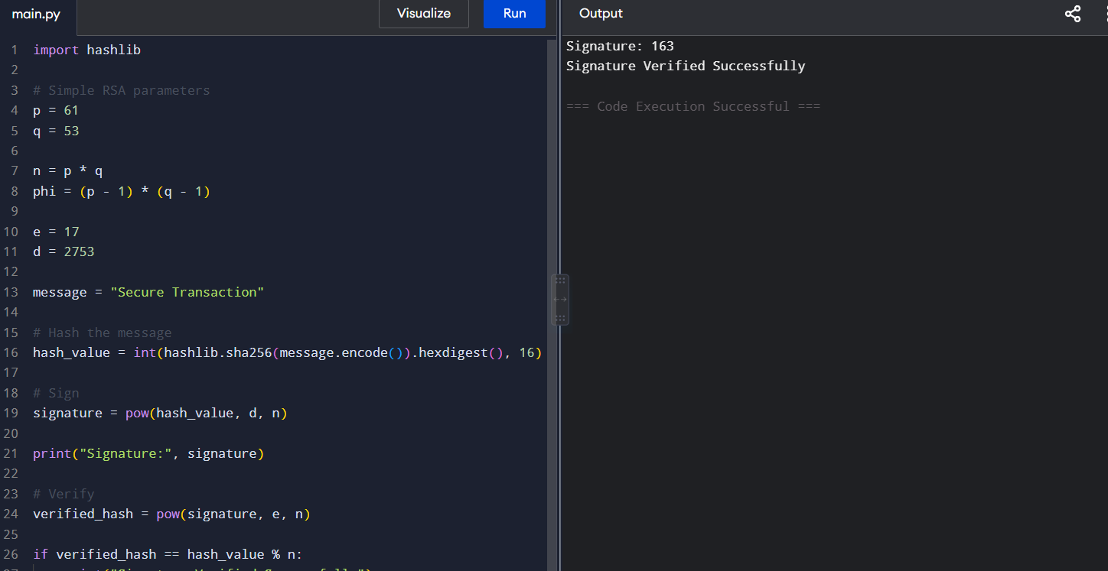

Analysis
- MD5 generates shorter hashes and executes faster.
- SHA-256 generates longer hashes and provides stronger security.
- MD5 is vulnerable to collision attacks.
- SHA-256 is significantly more collision resistant.

Result
SHA-256 provides better security and collision resistance than MD5 and is recommended for modern applications.

2. RSA Digital Signature Scheme

Aim
To implement RSA digital signatures for message signing and verification.

Theory
Digital signatures provide:
- Authentication
- Integrity
- Non-repudiation
Process:
- Hash the message.
- Sign the hash using private key.
- Verify using public key.

Program
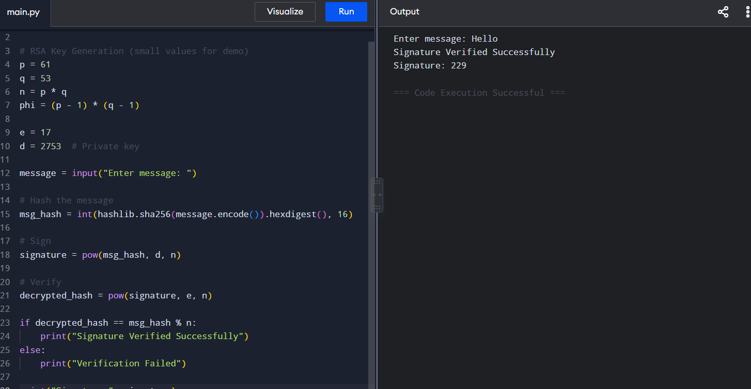

Analysis
- Any modification of the message invalidates the signature.
- Only the owner of the private key can create a valid signature.
- Ensures integrity and authentication.

Result
RSA digital signatures successfully provide authentication, integrity, and non-repudiation.

3. HMAC Implementation

Aim
To implement HMAC and compare it with a simple hash integrity check.

Theory

Simple Hash
Hash(Message)
Anyone can recompute the hash.

HMAC
HMAC(Key + Message)
Requires a secret key.

Python Program

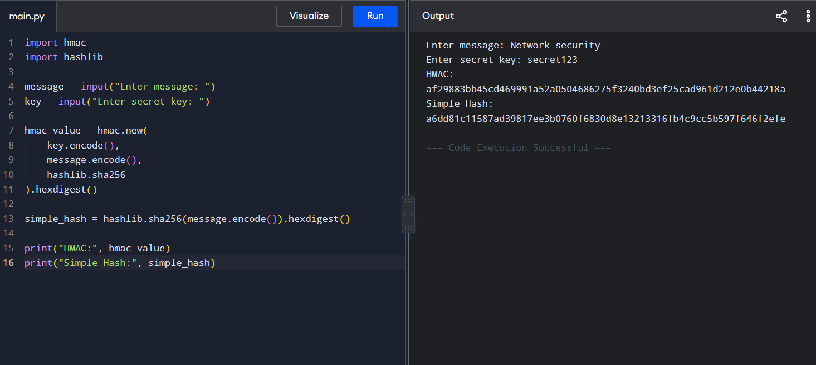

Analysis
Feature | Simple Hash | HMAC
Integrity | Yes | Yes
Authentication | No | Yes
Secret Key | No | Yes
Tamper Protection | Weak | Strong

Result
HMAC provides stronger security than simple hashing because it includes a secret key.

4. Simplified Kerberos Authentication

Aim
To simulate ticket generation, distribution, and validation using Kerberos concepts.

Theory
Kerberos uses:
- Client
- Authentication Server
- Ticket Granting Server
- Service Server
Authentication is performed using tickets and timestamps.

Python Program
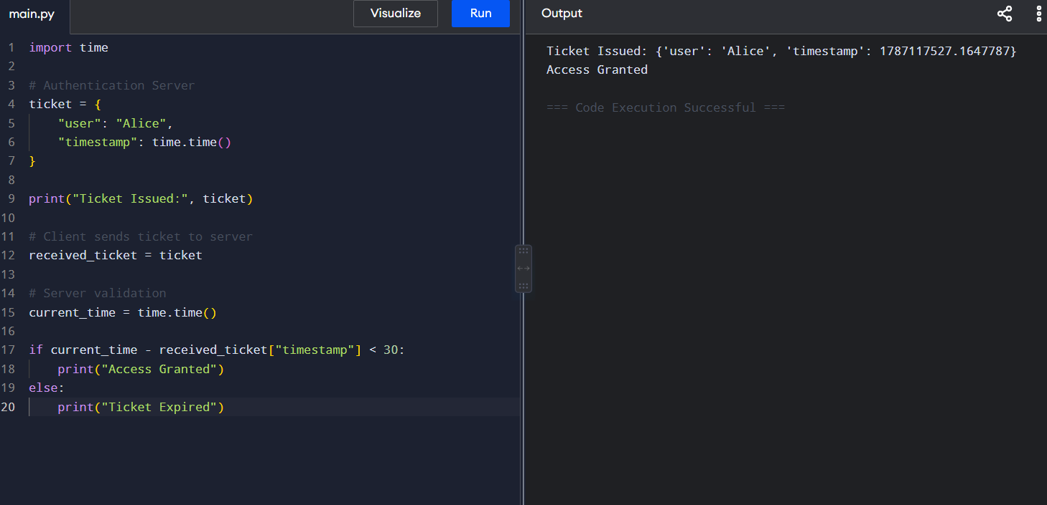

Analysis
- Tickets contain timestamps.
- Expired tickets are rejected.
- Replay attacks become difficult because old tickets are invalid.

Result
Kerberos effectively prevents replay attacks through ticket validation and timestamp checking.

5. Schnorr Digital Signature Scheme

Aim
To implement a simplified Schnorr digital signature scheme and evaluate its security.

Theory
Schnorr signatures are based on:
- Discrete logarithm problem
- Compact signatures
- Fast verification
Used in modern cryptographic systems.

Python Program
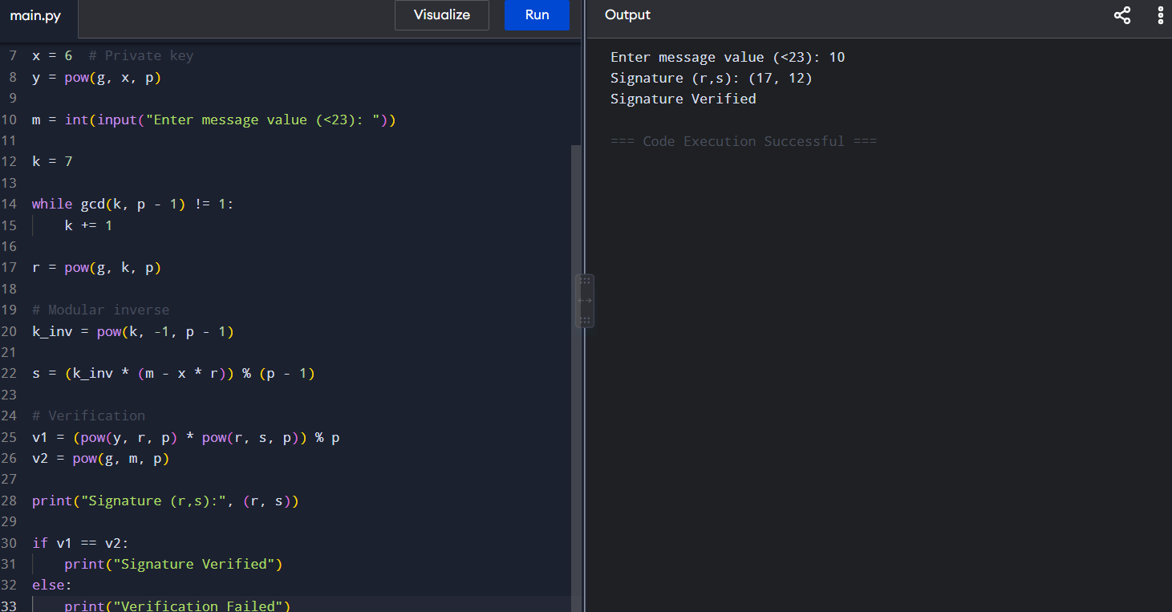

Analysis

Advantages
- Smaller signatures.
- Faster verification.
- Strong mathematical security.
- Suitable for resource-constrained systems.

Comparison with RSA
Feature | RSA | Schnorr
Key Size | Large | Smaller
Signature Size | Larger | Smaller
Verification Speed | Moderate | Faster
Security Basis | Factoring | Discrete Log

Result
Schnorr signatures provide efficient and secure digital signatures with smaller signature sizes and faster verification compared to traditional RSA-based approaches.

